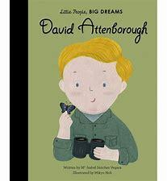  Summer – Fun on the Farm  Reception – David Attenborough |  | Experiences:  This term, the children will learn about different types of living things such as farm animals and mini-beasts and explore different types of plants and flowers. The children will learn about different types of pets, what makes a good pet, which animals live on a farm, how farms run, animal lifecycles and compare and sort animals. The children will understand the world around them by making observations of a butterfly’s lifecycle and have hands on experiences such as planting fruit and vegetables. The children will go on a trip to a farm where they have the opportunity to ask questions, feed animals and discuss real life experiences.
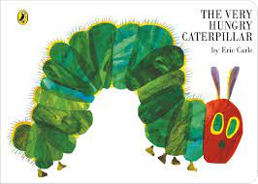
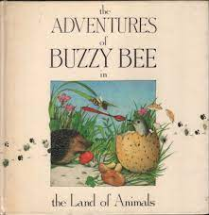
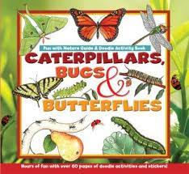
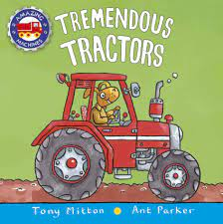
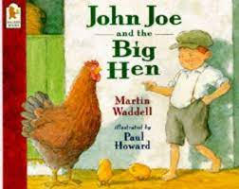
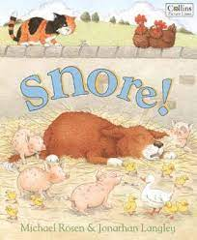
Books
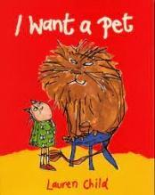
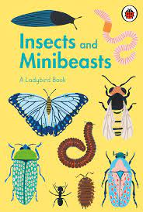

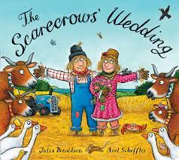
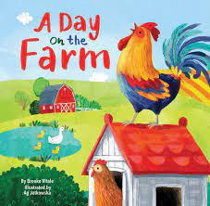
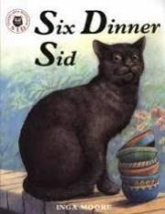
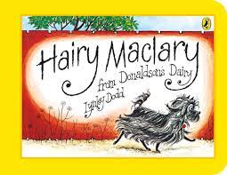
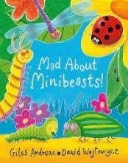
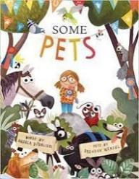
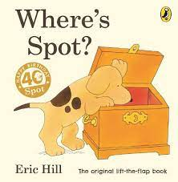
Key Vocabulary
Pets/Animals:
dog, cat, animal, snake, mouse, lion, tiger, sheep, bark, bird, domestic, donkey, horse, fish, hedgehog, groomer, kitten, kennel, fole, lizard, parrot, rabbit, rat, reptile, scales
Planting/Weather:
sun, water, seed, soil, leaf, mud, weather conditions, planting, plant, stem, rain
Farm:
farm, animals, crops, tractor, farmer, field, shovel, vegetable, scarecrow, bale of hay, chicken, sheep, cow, duck, horse, pig, chick, lamb, calf, duckling, piglet, udder, wheat grains, hen, duck
Minibeasts:
lifecycle, butterfly, bee caterpillar, beetle, ladybird, minibeast, eggs, chrysalis, tadpole, froglets, frogs, spider
PSED:
emotion, feelings, happy, sad, angry, afraid, excited, disappointed, surprised, tired, friendly, unfriendly, kind, sorry, proud, jealous, worried, ashamed, embarrassed, confused, anxious, joyful
Communication and Language  Skills:  Listening, attention and understanding:  - Have a back-and-forth conversation with a group about the same topic  - Ask relevant why/how questions  - Make relevant comments about a topic they have recently learnt with a small group/whole class  - Make relevant comments on the characters and the plot of the story and justify reasons with the whole class/small group  Speaking:  - To express their ideas and feelings in the present, future and past tense  - To use participate in whole class discussions offering own ideas (I think...) | Expressive Arts and Design  Skills:  Creating with Materials:  - To recognise, name, draw and categorise 2D shapes  - To construct a form with a purpose in mind  - To identify differences between textiles, such as see-through and opaque/light and heavy  - Safely use and explore a variety of materials, tools and techniques, experimenting with colour, design, texture, form, and function  - Share their creations, explaining the process they have used  - Make use of props and materials when role playing characters in narratives and stories.  Being Imaginative and Expressive:  - Charanga Music: Our World  - To understand how to hold and play an instrument with care  - To express feelings in music by responding to different moods in a music score  - To choose different instruments, including the voice, to create sound effects in play  - To choose an instrument to make a specific sound  To play a instrument to a steady beat  Exploring Habitats:  Leaf and grass rubbings - put leaf under paper and rub over top using crayons on their side.  Minibeasts  Creating minibeasts using nature, drawing minibeasts.  Underwater Creatures  Paintings using water, inks and watercolour.  Animal Masks  Making painted animal masks using poster or acrylic paints.  Max Ernst  Frottage landscapes for habitat drawings.  Clare Youngs  Animal collages.  Collage  Creating animal collages using a range of found papers.  3D  Assemblages of natural found objects to create bugs and minibeasts.  Printing  Printing from leaves to explore natural habitats- could be used within collage as papers. | Physical Development  Skills:  Gross Motor Skills:  - Fun and Games  - Working with others  Fine Motor Skills:  - Can cut with accuracy  - Hold a pencil effectively in preparation for fluent writing – using the tripod grip in almost all cases  - Use a range of small tools, including scissors, paint brushes and cutlery  - Begin to show accuracy and care when drawing. | Personal, Social and Emotional Development  Skills:  Self-Regulation:  - Modify your plan during play  - Participate in turn taking games with a group  - To regulate behaviour using a technique  - To stop play and conversation when asked by an adult and follow instructions involving several ideas and actions  - To regulate behaviour using a range of techniques  Managing Self:  - Try to follow class and game rules  - To show independence, resilience and perseverance in the face of a challenge  Building Relationships:  - To listen to the ideas of other child and agree on a solution and compromise
Understanding the World
Skills:
Past and Present:
- To use everyday language related to time (present, future and past)
- To talk about the past and present events in my life and my family for example, comment on images and familiar situations in the past such as going for a local walk and pictures of themselves around the classroom from throughout the year
- To use past, present and future forms accurately when talking about events that have happened or are about to happen
- To answer why questions about my experiences and responses to stories
- Compare farms in Clayton past/present
- To answer how questions about my experiences and responses to stories
- To recount an event verbally and written (labels and pictures)
- Make a whole class timeline of the school year
People, Culture and Communities:
- Our World: Understand that some places are special to members of their community.
- Describe their immediate environment using knowledge from observation, discussion, stories, non-fiction texts, and maps. For example, explore maps of Thornton Hall farm before the visit and draw out information, create a map of the farm from memory/pictures
The Natural World:
- To observe the growth of seeds and talk about the changes
- To learn and know the lifecycle of a butterfly
- To learn and know the lifecycle of a frog (observe frog spawn in the top garden)
- To know that weather can change from day to day and know the vocabulary to describe weather precisely, windy, breezy, cloudy, dry, rainy, foggy, sunny, hot, warm, cold, cool
- To match what clothing to wear in different weather conditions
- To record weather over a week or month
- To know some signs of summer
Trips / Visitors: Thornton Hall Farm, looking after guinea pigs for a week, May Day Parade

