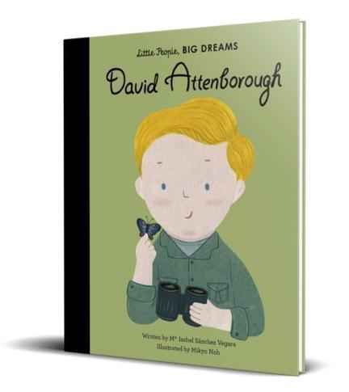David Attenborough Class

Reception Newsletter

Summer Term

Welcome back to school for the start of the Summer term!

Last term, we saw the children develop as learners and young people. The children have made great progress with their learning as well as developing their social, emotional and personal skills. We can’t wait to watch the children to continue to thrive and learn through their final term and start their journey into Year 1.

If you have any questions, please do not hesitate to contact a member of the Reception team.

This term’s topic is called ‘Fun on the Farm’. The children will be learning about different living things such as animals and plants. We will be starting the term learning about pets and farm animals and finishing with mini-beasts. We would love to see pictures of the children’s pets outside of school, please send pictures into Seesaw to spark discussion in class.

We will be planting our own plants and trying different foods. We will be focusing on fiction and non-fiction books including, ‘I want a Pet’, ‘The Hungry Caterpillar’, ‘A Day on the Farm’, ‘Why Living Things Need Homes’, ‘Six Dinner Sid’ and many more!

Reading at home is a vital to help your child progress and become a

lover of reading. We ask for you to read the decodable phonics book at least 3

times a week. Please ensure you sign your child's reading record each time your child has read. The children will take phonics reading books home on

Thursdays and will need to return them by the following Tuesday.

We visit the library every Monday. The children independently choose a book to

take home to read that week, please ensure library books are brought back to

school ahead of Monday's library visit. If you have any questions, please do not

hesitate to contact a member of the Reception team.



Uniform and Water Bottles:

Please ensure all of the uniform you send your children in is fully named. It makes it much easier for it to be returned to its rightful owner!

The children have a P.E lesson every Wednesday, please ensure P.E kit is worn on this day.

Please ensure children bring a water bottle to school filled **with water only.**

As it is the summer term, the children will be outside more please ensure sun cream is put on before school and children come to school with sun hats if necessary.

