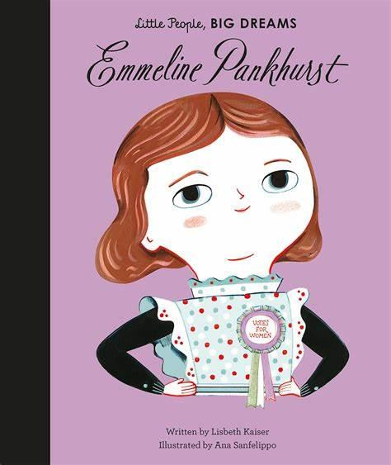

**PE**

PE continues to be on a **Tuesday**. Please come to school dressed in your full kit: black jogging bottoms and hoody top with a house colour t-shirt. As we will be aiming to do PE lessons outside you may wish to send your child in with sun cream on. Please make sure that your water bottle is brought in and full especially on PE days.

**Reading**

Reading books will continue to be handed out on **Thursdays** and need to be returned **Tuesdays**. Please log your child’s reading in their reading record and read at least three times per week.

Year 2 will visit the library every other week. Your child will be able to bring a new book home provided they have returned their previous one.

**Personal belongings**

Please ensure children do not bring in personal belongings.

Please **name** label absolutely everything your child brings to school including their **lunch box** (if they bring one).

**Coats and jumpers** are regularly taken on and off and will usually be returned if clearly named.

**Year 2 – Emmeline Pankhurst**

Welcome back, we hope you are well rested and ready for the Summer term.

Mrs Haxby & Mrs Roddis

**Filey Trip**

We are looking forward to our trip to the seaside on **Thursday 5th June 2025.** Please ensure the children are in school for **7:30am** and are collected at **4:30pm** unless otherwise stated on Ping. Don’t forget your donation of **£2** if your child would like an ice cream and their disposable **packed lunch** if that is what you stated. The children are allowed to wear non-uniform on the day of the trip but please send children with a purple school jumper and suitable footwear for walking to the beach.

**Family Breakfast**

W/B 28.4.25 – French

Summer 2 Dates to be confirmed

**Important Dates**

**02.05.25** – CVPS May Day

**05.05.25** – Bank Holiday Monday (school closed)

**09.05.25** – Year 2 Parent Afternoon

**15.05.25** – Census Day

**16.05.25** – Art and DT Showcase

**23.05.25** – Wellbeing Day

**23.05.25** – End of half-term

**04.05.25** – School re-opens

**5.6.24 –** Year 2 Trip to Filey!

**13.06.25** – Father’s Day shop

**10.07.25** – CVPS Sports Day

**Summer Curriculum**

Across the term, we will be exploring different areas of the world and researching significant individuals throughout history.

Over this term, Year 2 will be learning about how Bradford is different to other places in the world. This will include a focus on places in our country and places on other continents. We will also be completing some fieldwork during our visit to Filey as an extension of our coastline topic last term.

As part of our history topic, we will be focusing on Grace Darling and researching why she was important. Furthermore, we will discover the impact she has had on history and why we remember her. We will explore the history of seaside holidays and how they have changed in the last 100 years. Our trip to the beach will be a perfect fit to this topic!

Year 2 will also be learning about animals and how they grow over time, this will include exploring life cycles and finding out how certain animals survive in their habitats.

**For more information, please see the school website for our Y2 Medium-Term Plan.**

**Water Bottles**

Children are encouraged to bring water bottles to school as it is important that we are hydrated so we can work and be focused fully. Children are not to bring water bottles with spray functions on them.

Summer Term 2025