History  Why is Grace Darling significant?  Knowledge:  - To understand how events beyond living memory. To learn about the lives of significant individuals in the past who contributed to national and international achievements.  How have seaside holidays changed from the past?  Knowledge:  - To understand where in the world and when in the past we are learning about. To understand chronological duration. To understand how events beyond living memory. | Science  Animals including Humans – How do animals grow over time?  Knowledge:  - Talk about how to look after a pet  - Describe how animals help humans.  - Talk about baby animals and their parents.  - Describe how baby animals change as they grow. Notice that animals have offspring which grow into adults.  - Compare baby animals with their parents and other baby animals.  - Find out about and describe the basic needs of animals, including humans, for survival (water, food and air).  - Describe the importance for humans of exercise, balanced diets, and hygiene.  Scientific Enquiries:  - How does a shark survive in the ocean?  - How do animals grow over time? (observing over time)  Plants – How can I look after the plants in our garden?  Knowledge:  - Find out and describe how plants need water, light and a suitable temperature to grow and stay healthy.  - Use the local environment throughout the year to observe how plants grow.  - Observe and describe how seeds grow into mature plants.  Scientific Enquiries:  - What does a plant need to grow and stay alive?  - Growing sunflowers (observing over time) | Geography  How is Bradford different from Newfoundland & Labrador?  Knowledge:  - Understand geographical similarities and differences through studying the human and physical geography.  - Use simple geographical vocabulary to identify key human and physical features of different environments.
Computing  Artificial intelligence – video creation & presentations  - Use technology purposefully to create, organize, store, manipulate and retrieve digital content.  - Recognise common uses of information technology beyond school.  - Use Artificial intelligence to create videos and presentations. | Emmeline Pankhurst  Summer Curriculum  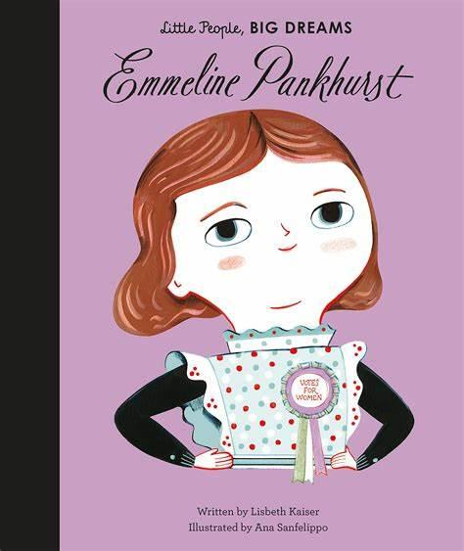 | R.E  How and why do some people pray?  (Buddhism, Christianity and Islam)
PSHE  My Body, Safety and Risk  - Human life cycle  - Brilliant bodies  - Safety and risk  - Safety at home  - Road safety  - Accidents and emergencies  Hurtful Behaviour  - Feeling lonely  - Bullying  - Unkind words  - Kindness  - Secrets and surprises |  | P.E  Rounders  - Agility, hand-eye coordination, batting, running.  Athletics  - Master basic movements including running, jumping, throwing and catching, as well as developing balance, agility and co-ordination.
Art  Artist: Vincent Van Gough  Drawing, Painting, 3D  Formal Element: Line, Colour, Shape  - Develop imagery as a means for expressing and communicating ideas.  - Mix paint to create secondary colours.  - Understand how artist use war and cool colours to express different moods. | Design Technology  Cooking and Nutrition - a balanced diet.  - Design, make and evaluate.  - Design purposeful, functional, appealing products for themselves and other users based on design criteria.  - Select from and use a range of tools and equipment to perform practical tasks.  - Select from and use a wide range of ingredients  - Evaluate their ideas and products against design criteria. | Music  Friendship Song  - Listen and appraise  - Performance

