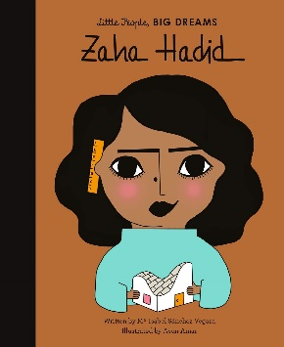

**Year 3 Trip**

Our Year 3 trip **(school camp out)** is in Summer 2.

A second follow up letter will be going out very soon, with a list of all the things the children will need!

**PE**

Our PE is on a **Tuesday**. Please come to school dressed in your full kit: black jogging bottoms and black hoodie with a house colour t-shirt. Make sure that your water bottle is brought in full, especially on PE days.

**Summer Curriculum**

In Summer, we are going to be exploring different ancient civilizations, in particular, Ancient Egypt. We will be looking at the impact of Ancient Egyptian’s rules on civilization.

In science, we will be concentrating on Light and how important light is for our everyday life. The difference between natural and non-natural light sources and what is the most powerful natural light source of them all. Also, we will explore the history and invention of the first light bulb. Throughout the topic we will use key vocabulary like transparent, translucent and opaque.

In Geography, we will be learning about the Amazon River in North America (Brazil), the importance of rivers to us all and developing our map reading skills by locating North America (Brazil) and the Amazon River.

**Important Dates**

**03.05.25** – May Day Parade

**06.05.25** – May Day Bank Holiday (School Closed)

**23.05.25** –End of half term

**04.06.25** – School re-opens

**04.07.25 -** Transition Day

**10.07.24** – Sports Day

**19.07.24** – End of Summer term

**14.07.25 –** Annual Reports

**Mrs Hampson and Mr Kowal**

Year 3 – Zaha Hadid

Welcome back from your Easter break. We are so happy to see you all back and excited to have lots of fun and achieve our best! This is our last term in Year 3!

**Reading**

At Clayton Village, we want all children to be readers and it is a value we encourage. Not only for academics but more for joy and escapism from the everyday world.

Children in Year 3 should read at **least 3 times a week.** They do not need to read aloud to an adult but you are encouraged to ask your child questions about what they have read.



We would also like you to promote the use of **Emile** at home. This is a free app that the school subscribes to and help practice key skills in maths, reading and grammar.

**Water Bottles**

Children are encouraged to bring water bottles to school as it is important that we are hydrated so we can work and be focused fully. Children are not to bring water bottles with spray functions on them.

These will be stored by the sink and children will be encouraged to drink these at playtime and lunchtime. If a child requires a drink during a lesson, it is the teacher’s discretion to find a suitable time.

Summer Term 2025