History  Why was Baghdad a significant city?  Knowledge:  - Learn about a non-European society that provides contrasts with British history- early Islamic civilization including a study of Baghdad c. 900AD | Science  Space– Will I ever live on another planet?  Knowledge:  - Explain the shape and relative sizes of the Earth, Sun and Moon  - Explain why our shadows change and why we have day and night  - Explain about the Earth’s orbit around the Sun  - To describe the Moon’s phases and orbit of the Earth  - Describe the Solar System and man’s journey into space  - Name the 8 planets: Mercury, Venus, Earth, Mars, Jupiter, Saturn, Uranus and Neptune (Pluto reclassified as a ‘dwarf planet in 2006)  - To describe the moon as a celestial body that orbits a planet (Earth has one moon; Jupiter has four large moons and numerous smaller ones)  - describe the movement of the Earth, and other planets, relative to the Sun in the solar system  - describe the movement of the Moon relative to the Earth  - describe the Sun, Earth and Moon as approximately spherical bodies  - use the idea of the Earth’s rotation to explain day and night and the apparent movement of the sun across the sky  - explain that unsupported objects fall towards the Earth because of the force of gravity acting between the Earth and the falling object  Scientific Enquiries:  - How does the moon change over 28 days?  - The higher I drop the meteorite, the bigger the crater will be. |  | Geography  Would I prefer to live in Europe or Oceania?  Knowledge:  - Name and locate the countries of Oceania, identifying human and physical characteristics, key topographical features (including hills, mountains, coasts and rivers), and land-use patterns, including time differences.
Computing  Computer Networks – Search Engines  - To create and export an interactive presentation, including a variety of media, animations, transitions and other effects.  - To enhance digital photos and images using crop, brightness and resize tools. | Ada Lovelace  Summer Curriculum  The Rise and Fall of Baghdad  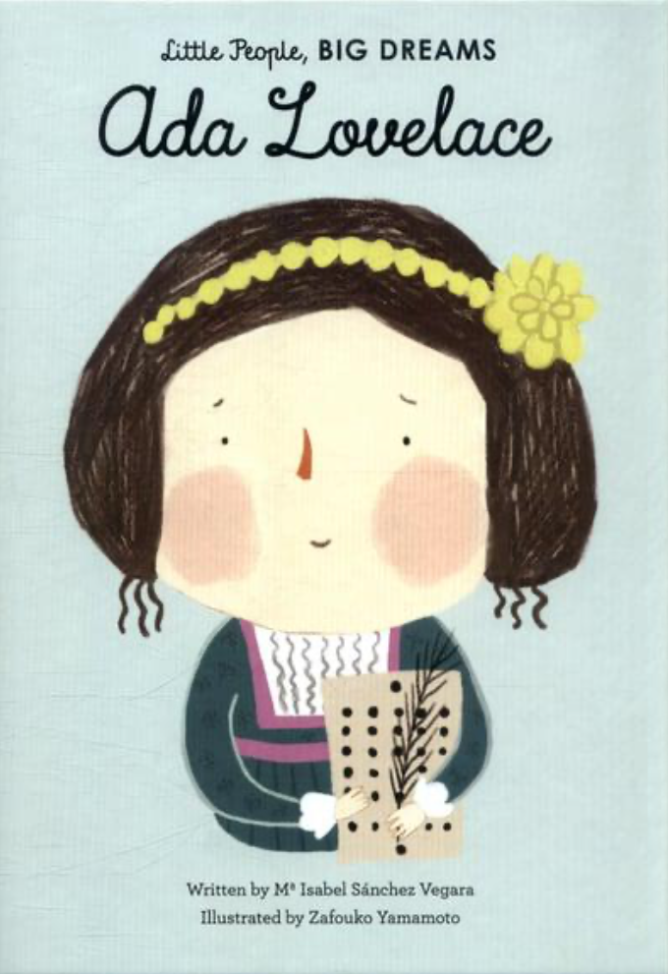 |  | R.E  Who should get to be in charge?  (Religions: Interfaith)
PSHE  Healthy Choices, First Aid and Safety  - Healthy habits  - Sleep hygiene  - Sun Safety  - Medicines and Household Safety  - First Aid  Behaviour, Respect and Friends  - Behaviour & Respect  - Friendships & Feeling Left Out  - Friendships  - Peer Pressure  - Loving Stable Familes  RSE lesson with the School Nursing Team |  |  | P. E  Athletics  - Use running, jumping, throwing and catching in isolation and in combination.  Cricket  - Play competitive games and apply basic principles suitable for batting and fielding.
Art  Zaha Hadid  Painting, Drawing & Collage  Formal Elements: colour, shape  - Use different tools to apply paint.  - Produce increasingly colourful and experimental paintings inspired by the different colours in the sky.  - Using images from Baghdad and Bradford children should draw and paint a silhouette of the building on top of their colourful painting. | Design Technology  Textiles – Waistcoats  - Consider a range of factors in my design criteria and use this to create a waistcoat design.  - Use a running stitch to join fabric and attach a secure fastening, as well as decorative objects.  - Evaluate my final waistcoat. | Music  The Fresh Prince of Bel-Air  Ukulele  - Listen, appraise and perform | MFL  Meet my French Family  - Listen attentively to spoken language and show understanding by joining in and responding.  - Explore the patterns and sounds of language through sound and meaning of words.  - Engage in conversations; ask and answer questions; express opinions and respond to those of others; seek clarification and help.

