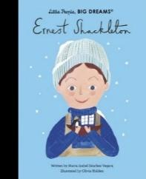

**Transition Day**

Please ensure you check with your child’s new secondary school for their Year 7 transition day.

**Revision**

As we are on the last stretch to SATs now, we would recommend your child engage in some revision at home. This does not need to be onerous because we do not want the children to feel stressed. Continuing to read 3 times a week would be extremely beneficial and ensuring they access a range of text types as well as poetry. They can access Emile where they can practise a range of skills as well as CENTURY. Any revision guides that you have purchased would also be useful. Remember little and often is better than hours of cramming on Sunday 11th May.

**First Aid**

This term, the children will be doing weekly first aid lessons with Mr Vigus. This will begin on the 11th June, 2025. As part of this, the children learn key skills on how to save somebody’s life and how to carry out vital first aid if a person is in danger.

**Family Breakfast**

W/B 28.4.25 – French

Summer 2 Dates to be confirmed

**Important Dates**

**2.05.25** – Medium term plan published on website

**02.05.25** – CVPS May Day

**05.05.25** – Bank Holiday Monday (school closed)

**W/B 12.05.25** – SATs Week

**24.05.24** – CVPS Wellbeing Day

**15.05.25** – Census Day

**16.05.25** – Art and DT Showcase

**23.05.25** – Wellbeing Day

**23.05.25** – End of half-term

**04.05.25** – School re-opens

**05.06.25** – 100% attendance Meal

**13.06.25** – Father’s Day shop

**19.06.25** – Mary Poppins Alhambra Trip

**10.07.25** – CVPS Sports Day

**16.07.25** – Y6 Prom

**18.07.25** – Y6 Graduation

**Summer Curriculum**

During the Summer term, Year 6 will be learning about the impact of WW2 on Britain. We will learn which countries were involved in the war and their location on a map. We will also understand the impact the war had on children as we look at evacuees.

In science, we will be learning about electricity; where it comes from and how many different ways we can make it. We will then look at how light travels and how many different colours white light can split up in to. We will carry out a series of investigations to find this out.

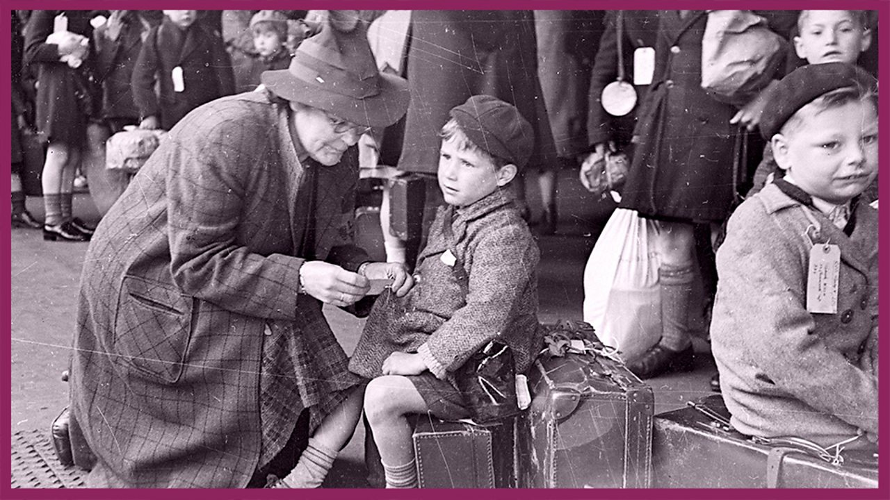

**PE**

Our PE is on a **Wednesday**. Please come to school dressed in your full kit: black jogging bottoms, black hoody and house colour t-shirt. All clothing should be plain with no patterns or large logos.

**SATs**

SATs will commence from W/B 12.05.25. It is vitally important that your child attends school every day and they are on time. The exam timetable is as follows:

|  |  |
| --- | --- |
| Monday 12th May 2025 | Grammar, Punctuation and Spelling Paper 1  Grammar, Punctuation and Spelling Paper 2 |
| Tuesday 13th May 2025 | English Reading |
| Wednesday 14th May 2025 | Maths Paper 1 (Arithmetic)  Maths Paper 2 (Reasoning) |
| Thursday 15th May 2025 | Maths Paper 3 (Reasoning) |

We will be offering a free breakfast for all Year 6 children every morning during SATs week. This gives them the opportunity to have a good breakfast as well as some social time with their peers and teachers to alleviate any worries that they may have. This will be a drop in session from 8am and there is no need to sign up.

**Miss Binder and Mrs Hickey**

Year 6- Ernest Shackleton

Welcome back to an important term for Year 6. This is the half term that we have been working towards all year; where the children will have the opportunity to showcase how brilliant they are during SATs.

Visit the School Website for this term’s medium-term plan and updates of our learning.

