History  World War Two  Why did Britain have to go to war?  Knowledge:  - A study of an aspect or theme in British history that extends pupils’ chronological knowledge beyond 1066. | Science  Electricity – What powers our world?  Knowledge:  - Associate the brightness of a lamp or the volume of a buzzer with the number and voltage of cells used in the circuit  - Compare and give reasons for variations in how components function, including the brightness of bulbs, the loudness of buzzers and the on/off position of switches  - Use recognised symbols when representing a simple circuit in a diagram.  Scientific Enquiries:  - Where does electricity come from and how many ways can it be created? (research)  - What effects the brightness of a bulb? (comparative and fair testing)  Light – Is that really me in the mirror?  Knowledge:  - Recognise that light appears to travel in straight lines  - Use the idea that light travels in straight lines to explain that objects are seen because they give out or reflect light into the eye  - Explain that we see things because light travels from light sources to our eyes or from light sources to objects and then to our eyes  - Use the idea that light travels in straight lines to explain why shadows have the same shape as the objects that cast them.  Scientific Enquiries:  - Light travels in straight lines. True or false? Prove it (pattern seeking)  - How many different colours can white light be split in to? (research) |  | Geography  How is life changing for Kenyans?  Knowledge:  - Human geography, including: types of settlement and land use, economic activity including trade links, and the distribution of natural resources including energy, food, minerals and water
Computing  Computer Networks: HTML  - Understand what HTML is and recognize HTML tags  - Know a range of HTML tags and remix a web page  - Create a webpage using HTML | Ernest Shackleton  Summer Curriculum  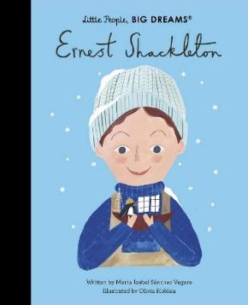 |  | R.E  What place does religion have in our world today?  Religions covered: Interfaith/ personal project
PSHE  Living in the Wider World  - What is money?  - Different attitudes about money  - Keeping safe  - New schools and classes: transition  Relationships Education  - Bullying or teasing  - Consent  - Attraction  - Human reproduction |  |  | P.E  Athletics and Cricket  - Use running, jumping, throwing and catching in isolation and in combination.  - Play competitive games, modified where appropriate and apply basic principles suitable for attacking and defending.
Art  Drawing  Painting  Textiles  Artist: Printmaking  - Drawing self-portraits focusing on tone and proportion. Reflect aspects of their personality or interests in their self-portraits.  - Using paints to understand the effect created by pop art painters.  - Exploring the works of Warhol/Blake and how they are a key figure in pop art.  History link – How does British pop art fit  into narratives of migration and journeys after WW2? | Design Technology  Electrical Systems- steady hand game  - Learn about skills developed through play and apply this knowledge in a survey of one or more children’s toys.  - Create a secure base for their game, with neat edges, that relates to their design.  - Make and test a functioning circuit and assemble it within a case. | Music  Music and Me  End of year performance  - Listen and appraise  - Performance | MFL  In a French Classroom  - Understand that every French noun is either masculine or feminine.  - Know that adjectives of size such as petit and grand are placed before the noun.  - Know that some words are cognates: they have the same spelling and meaning in French and English: le train, le taxi.  - Know that accents in French can change the sound of a letter.

