David Attenborough Class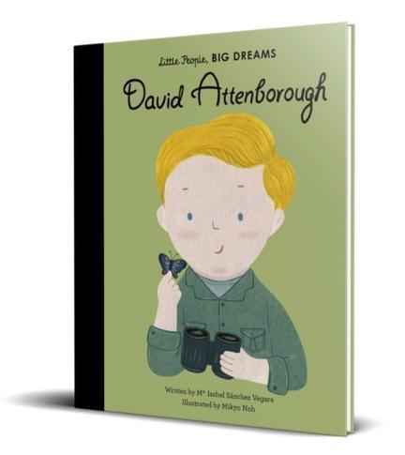

Reception Newsletter

Autumn Term



**Important Dates**

Parent Morning – 05.09.25

School Election Day – 06.10.25

Parents evening – 15.10.25

Halloween Disco – 22.10.25

Break up for half term – 24.10.25

Back to school – 03.11.25

Children in Need – 14.11.25

STEM Showcase – 27.11.25

Christmas Nativity Performance – 10.12.25

Christmas Dinner – 17.12.25

Christmas Disco – 18.12.25

Christmas Panto – 19.12.25

Break up for Christmas holidays – 19.12.25

Our topic this term is called ‘Home is Where the Heart is’. We will be focusing on fiction and non-fiction books including, Goldilocks, The Three Little Pigs, This is My Home, We are Family and many more! This theme helps support children develop a sense of community as a class, as part of our school family and of their local area – Clayton. We will be exploring past and present homes in our community. A lot of the first half-term is spent making sure children are settling into CVPS and learning the expectations and routines of school.

Welcome to school from your class teacher Miss Robinson and your teaching assistant Miss Stokes. We are delighted to welcome the children to Clayton Village Primary School, where they have all had a great start to the year! We are extremely impressed with how the children have started Reception. They have already started to learn many of the Reception routines and began to make new friends.

If you have any questions, please do not hesitate to contact a member of the Reception team.

Reading at home is vitally important to help your child progress and become a lover of reading. Our library is having a makeover and soon your child will be bringing home a library book to share with you. We will keep you updated on when we will be visiting the library. Group reading will start W/C 22.9.25. The children will bring a reading book home on Wednesdays and will need to return them by the following Monday. You will need to listen to your child read at least 3 times a week and record in their reading diary each week. This will then be checked by the class teacher.

Uniform and Water Bottles: Please ensure all of the uniform you send your children in is fully named. It makes it much easier for it to be returned to its rightful owner! Your child will require a named pair of wellies and a rain suit as we love to use our outdoor area in all weathers! If it is particularly sunny, a sunhat will be required. Children also need a named water bottle to be filled each day with **only water**. We use Seesaw to send pictures home of children’s work in school. Please see me for a Seesaw code if you do not have one.

**Personal belongings**

We ask that all personal belongings remain at home. Children do not need to bring any equipment from home.

However, they must bring their bag with them every Monday and Wednesday to have their book changed.

Please **name** label absolutely everything your child brings to school including their **lunch box** (if they bring one).

**Coats and jumpers** are regularly taken on and off and will usually be returned if clearly named.

For more information, please refer to the school website.