History  How am I making history?  Knowledge:  - Order three photographs correctly on a simple timeline.  - Use the terms ‘before’ and ‘after’ when discussing their timelines.  - Talk about three memories and place one of them on a timeline.  - Explain why memories are special and name four events that they celebrate throughout the year.  - Think of three ways they celebrate their birthday.  - Ask a visitor one question about childhood in the past.  - Know a similarity and a difference between childhood now and in the past.  - Add three ideas to a time capsule about themselves.  - Use key vocabulary to compare the present, the past and possible changes in the future. | Science  Animals Including Humans – All About Me  Knowledge:  - Learn how to identify, name, draw and label the basic parts of the human body and say which part of the body is associated with each sense.  Animals Including Humans – All About Animals  Knowledge:  - Learn how to identify and name a variety of common animals including fish, amphibians, reptiles, birds and mammals. They learn how to identify and name a variety of common animals that are carnivores, herbivores and omnivores. And finally, they learn how to describe and compare the structure of a variety of common animals (fish, amphibians, reptiles, birds and mammals including pets). | Geography  What is like here?  Knowledge:  - Locate three features on an aerial photograph of the school and know the name of the country and village, town or city in which they live.  - Make a map of the classroom with four key features, using objects to represent the distance and direction of features in the classroom.  - Recognise four features in the school grounds using a map.  - Explain how they feel about three areas of the playground and find out how others feel by looking at the results of a survey.  - Draw a design to improve three areas of the playground using the results from the survey.
Computing  Programming- simple algorithm  - Computational thinking  - Coding/ programming | Rosa Parks  Autumn Curriculum  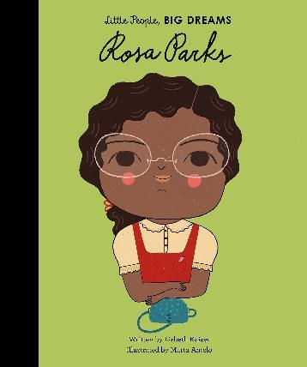  P.E  Invasion Game – Football  - Master basic movements including running, jumping, throwing and catching, as well as developing balance, agility and co-ordination, and begin to apply these in a range of activities.  - Participate in team games, developing simple tactics for attacking and defending.  Gymnastics  - Develop balance, agility and coordination. | Music  Hey You!  - Listen and appraise  - Performance
PSHE  The Friendship Bench  - I can tell you how people choose and make friends  - I can tell you what makes a good friend  - I can tell you how my friends make me happy and how I make my friends happy.  - I can tell you how I make others feel welcome and included.  - I know what to do if a friend makes me unhappy.  Angry Arthur  - I can tell you what appropriate and proportionate behaviour means.  - I can describe the 5-point scale for basic emotions.  - I can tell you why someone might have an inappropriate reaction and how they can recognise if they need support.  - I can tell you the importance of giving my brain a rest and some ways I like to relax.  - I can tell you how I take responsibility for my school environment. Including toilets/ shared spaces. |  | R.E  Which books and stories are important?  - Recognise special books and notice how they are treated.  - Explain how the Bible is a special book for Christians; the Qur'an is a special book for Muslims; the Torah is a special book for Jewish people and the Guru Granth Sahib is a special book for Sikhs.  - Suggest meanings for stories with a moral / message from each special book.  - Talk about how people might follow moral examples from stories in order to live a good life.  Why are festivals important in a community? To know:  - Celebrations help to mark and remember special times.  - Christians celebrate Harvest Festival by showing gratitude and giving to others.  - At the festival of Sukkot, Jewish people build shelters and remember the story of Moses in the desert.  - Muslims celebrate Eid at the end of the month of fasting during Ramadan.  - Hindus and Sikhs celebrate Diwali with diva lights and fireworks. Hindus remember the story of Rama and Sita. Sikhs remember the story of Guru Hargobind.  - Religious and non-religious celebrations may include candles, gifts and special food.
Art  Drawing  Painting  Collage  Artist: Pablo Picasso  Formal element: Line, Shape, Pattern, Colour, Tone  - Make observational drawings  - Mix thick paint (textured)  - Mix thin paint (watercolour)  - Gather and sort the materials needed to make a collage  - Cut and tear paper and card for collages | Design Technology  Cooking and Nutrition - Smoothies  - Describe fruits and vegetables and explain how to identify fruits.  - Name a range of places that fruits and vegetables grow.  - Describe basic characteristics of fruit and vegetables.  - Prepare fruits and vegetables to make a smoothie.

