History  How was school different in the past?  - Correctly order and date four photographs on a timeline and add some dates.  - Ask one question about schools in the past.  - Make one comparison between schools in the past and present.  - Use sources to research and develop an understanding of what schools were like 100 years ago.  - Identify three features of a classroom now and a classroom 100 years ago, identifying some similarities and differences.  - Recognise two similarities and two differences between schools now and schools in the past.  - State whether they would have preferred to go to school in the past or not and explain why. | Science  Animals including Humans – How can I look after myself?  - notice that animals, including humans, have offspring which grow into adults  - find out about and describe the basic needs of animals, including humans, for survival (water, food and air)  - describe the importance for humans of exercise, eating the right amounts of different types of food, and hygiene.  Animals including Humans - How do animals grow over time?  - notice that animals, including humans, have offspring which grow into adults  - find out about and describe the basic needs of animals, including humans, for survival (water, food and air)  - describe the importance for humans of exercise, eating the right amounts of different types of food, and hygiene. | Geography  Would you prefer to live in a hot or cold place?  - Name and locate the seven continents on a world map.  - Locate the North and the South Poles on a world map.  - Locate the Equator on a world map.  - Describe some similarities and differences between the UK and Kenya.  - Investigate the weather, writing about it using key vocabulary and explaining whether they live in a hot or cold place.  - Recognise the features of hot and cold places.  - Locate some countries with hot or cold climates on a world map.
Computing  Programing - Knock Knock Joke  - Understand what algorithms are; how they are implemented as programs on digital devices.  - Create and debug simple programs  - Use logical reasoning to predict the behaviour of simple programs | Emmeline Pankhurst  Autumn Curriculum | R.E  How can we make good choices?  - The Ten Commandments are ten basic rules for Jews and Christians.  - Most Muslims follow the Five Pillars of Islam. The first pillar is Shahadah – a statement of faith. Zakat means giving to charity.  - Sikhs worship at the gurdwara. The free food kitchen in the gurdwara is called a langar hall.  - Buddhists and Hindus follow the principle of 'karma' – actions today will affect tomorrow.  - Stories with a moral help us to think about the consequences of our actions.  How do stories help Hindu’s live their lives?  - Recognise that many stories have a message  - Retell the story about Ganesha and the party and express ideas about the message that kindness is better than boasting.  - Retell the story of the Four Friends. Express ideas about how working together with different people can solve problems.  - Retell the story of the Six Men and the Elephant. Express ideas about different ways of looking at the same thing.  - Talk about what is meant by a mystery. Retell the story about Waiting for God and how God can be found everywhere.  - Retell the story about Mother Ganges comes to India and the message that the natural world must be treated gently.  - Retell the story about Krishna and the message that God can be seen in many different forms.
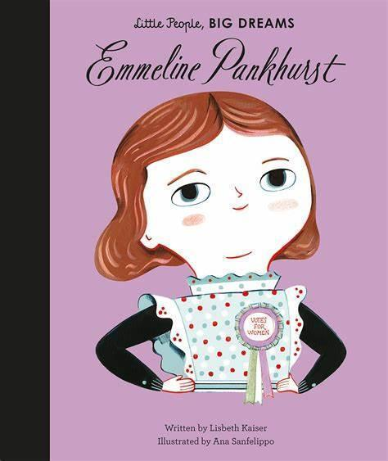  PSHE  Story Project  Perseverance, Pressure and Self-Belief  - I can explain why mistakes help my learning.  - I can tell you how I have learnt from my mistakes.  - I can tell you how respecting myself and being kind to myself can help me to be happy.  - I can tell you what the word perseverance means.  - I can tell you what helps me to persevere.  Anger, Calm, Difference, Emotions, Fair, Reflection and Respect  - I can explain that it is ok to feel all emotions  - I can explain why it is important to reflect on how I manage my emotions  - I can tell you what strategies help me to calm down  - I can tell you what is fair/unfair, right/wrong and kind/unkind  - I can tell you why it is good that people are different. |  | P.E  Invasion Game - Rugby  - Agility, hand-eye coordination, kicking, running, throwing, catching  Gymnastics  - Shapes, balance, flexibility, sequences, rolls
Art  Drawing  Painting  Artist: David Hockney  Formal Element: Line, Shape, Pattern  - Confidently use charcoal, pencil and pastels  - Choose colours and mix paint to express a particular mood in artwork  - Use key vocabulary to demonstrate knowledge and understanding in this strand: collage, squares, gaps, mosaic, features, cut, place, arrange | Design Technology  Mechanisms - Moving Monsters  - Design, make and evaluate  - Design purposeful, functional, appealing products for themselves and other users based on design criteria.  - Select from and use a range of tools and equipment to perform practical tasks.  - Evaluate their ideas and products against design criteria. | Music  Hands, Feet, Heart  - Listen and appraise  - Performance

