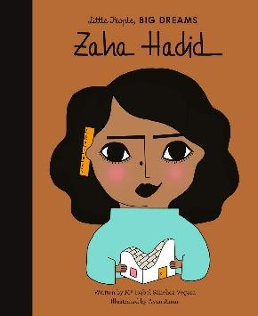

**Important Dates**

Parent Morning – 05.09.25

School Election Day – 06.10.25

Parents evening – 15.10.25

Halloween Disco – 22.10.25

Break up for half term – 24.10.25

Back to school – 03.11.25

Children in Need – 14.11.25

STEM Showcase – 27.11.25

Christmas Church Performance – 10.12.25

Christmas Dinner – 17.12.25

Christmas Disco – 18.12.25

Christmas Panto – 19.12.25

Break up for Christmas holidays – 19.12.25

**Autumn Curriculum**

In History, we will be studying the stone age, iron age and bronze age. We will use archaeological evidence to learn about the changes from the Stone to the Bronze Age and answer historical questions.

In Science, we will be studying animals including humans. We will be looking at why humans move differently to animals. In addition, this term, we will be working scientifically when looking at forces and magnets. We will be taking part in lots of investigations to discover new things. In Year 3, we will be having weekly ukulele lessons on a Tuesday.

For further information on other subjects, please check the class page on the school website to keep up to date with our medium term plan for Autumn term.

**Mrs Hampson and Mr Kowal**

Year 3 – Zaha Hadid

Welcome back to Clayton Village, we are so happy to see you all back. We are excited to have lots of fun and achieve our best!

Mrs Hickey will be teaching the class on Mondays, Tuesdays and Wednesdays and Mrs Whitaker on Thursdays and Fridays. They will also continue to have specialist teaching from Mr Waterman, Mrs Battye and Mrs Topley. Mr Kowel is our class TA.

**A reminder for parents to name label absolutely everything your child brings to school including their lunch box (if they bring one).**

**PE**

Our PE is on a **Thursday** this year. Please come to school dressed in your full kit: black jogging bottoms and hoody top with a house colour t-shirt. Make sure that your water bottle is brought in and full especially on PE days.

Autumn Term 2025

**Reading**

At Clayton Village, we want all children to be readers and it is a value we encourage. Not only for academics but more for joy and escapism from the everyday world.

Children in Year 3 should read at **least 3 times a week.** They do not need to read aloud to an adult but you are encouraged to ask your child questions about what they have read. We will have a weekly timetabled ‘Book Talk’ session where children and staff can share and recommend their favourite books. We will also have a DEAR (drop everything and read) session where children can enjoy their reading book.

We will be visiting the library fortnightly on Thursdays so your child will have another opportunity to select a book.

**Water Bottles**

Children are encouraged to bring water bottles to school as it is important that we are hydrated so we can work and be focused fully. Children are not to bring water bottles with spray functions on them.

These will be stored by the sink and children will be encouraged to drink these at playtime and lunchtime. If a child requires a drink during a lesson, it is the teacher’s discretion to find a suitable time.