History  Were the Vikings raiders, traders or something else?  Knowledge:  - Extending their understanding of different societies, children learn about the Vikings and the struggle for Britain.  - They develop their chronological understanding and explore new types of sources, including oral histories, to learn about the Vikings and the impact they had on local British communities.  - Using historical enquiry techniques, pupils investigate whether the Vikings were raiders, traders or settlers. | Science  Animals Including Humans - What is the circle of life?  Knowledge:  - Describe the changes of humans from birth to death  - Name and order the different stages of human life e.g. foetus, baby, child, adolescent, adult, old age  - Describe how a baby changes physically as it grows and what it is able to do  - Describe the changes as humans develop to old age  Space– Will I ever live on another planet?  Knowledge:  - Explain the shape and relative sizes of the Earth, Sun and Moon  - Explain why our shadows change and why we have day and night  - Explain about the Earth’s orbit around the Sun  - To describe the Moon’s phases and orbit of the Earth  - Describe the Solar System and man’s journey into space  - Name the 8 planets: Mercury, Venus, Earth, Mars, Jupiter, Saturn, Uranus and Neptune (Pluto reclassified as a ‘dwarf planet in 2006)  - To describe the moon as a celestial body that orbits a planet (Earth has one moon; Jupiter has four large moons and numerous smaller ones)  - Describe the movement of the Earth, and other planets, relative to the Sun in the solar system  - Describe the movement of the Moon relative to the Earth  - Describe the Sun, Earth and Moon as approximately spherical bodies  - Use the idea of the Earth’s rotation to explain day and night and the apparent movement of the sun across the sky  - Explain that unsupported objects fall towards the Earth because of the force of gravity acting between the Earth and the falling object . |  | Geography  Who Lives in Antarctica?  Knowledge:  - Describe what lines of latitude and longitude are, giving an example.  - Understand that the Northern and Southern Hemispheres experience seasons at different times.  - Define what climate zones are.  - Understand Antarctica has a polar climate made up of ice sheets, snow and mountains.  - Describe Antarctica’s location in the far south of the globe.  - State that tourism and research are the two main reasons people visit Antarctica.  - Describe equipment researchers might use and clothes they wear.  - List some of the research carried out in Antarctica.  - State the outcome of Shackleton’s expedition.  - Successfully plot four-figure grid references at the point where the vertical and horizontal line meet.  - Describe a similarity and difference between life in the UK and life in Antarctica.  - Confidently use the zoom function on a digital map.  - Begin to recall the eight points of a compass, following at least four of them.  - Recognise and describe features on their school grounds from an aerial map.  - Draw a map of the route they take on an expedition.  - State one thing that went well on the expedition and one aspect that did not go as hoped.
Computing  Programming- quizzes in scratch  - design, write and debug programs that accomplish specific goals, including controlling or simulating physical systems; solve problems by decomposing them into smaller parts  - use sequence, selection, and repetition in programs; work with variables and various forms of input and output  - use logical reasoning to explain how some simple algorithms work and to detect and correct errors in algorithms and programs  E-safety  - Understand the terms plagiarism and copyright and be aware of the implications of copying and sharing content without permission. | Ada Lovelace  Autumn Curriculum  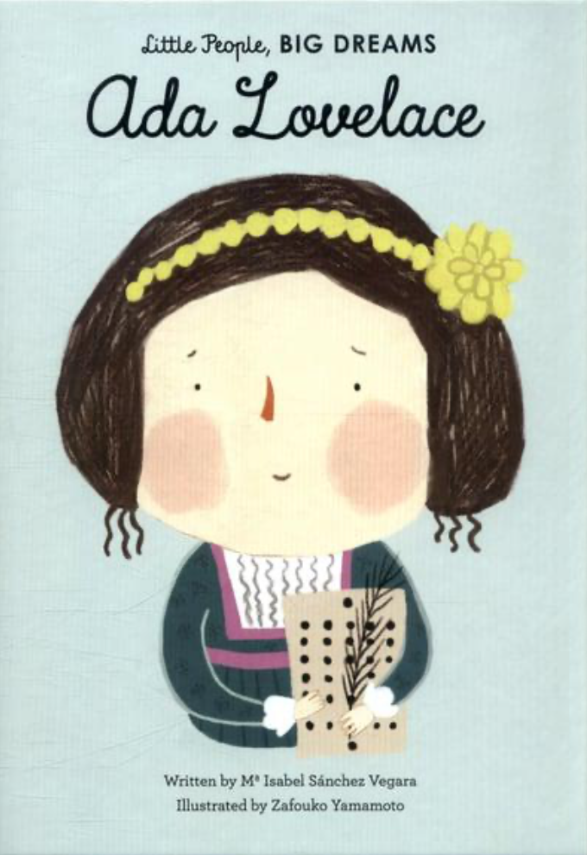 |  | R.E  How do Buddhists live a meaningful life?  Knowledge:  - Define and describe happiness and contentment.  - Define and describe different types of suffering and explore how suffering might be overcome.  - Identify Siddhartha Gautama and explain why and how he searched for the answer to suffering.  - Summarise the story of Prince Siddhartha and explain its importance to Buddhists.  - Relate the Four Noble Truths to your own life.  - Explain guidelines for living that help to overcome suffering and respond to the Buddhist Precepts as a means of living a good life.  How and why are Jewish festivals celebrated today?  Knowledge:  - Rosh Hashanah is a celebration of the start of the Jewish New Year and is a time to reflect.  - Yom Kippur is known as the ‘Day of Atonement’ and is a time to ask God’s forgiveness for any sins.  - Sukkot commemorates God’s protection during the period after the Exodus.  - Shavuot commemorates the revelation of the Torah.  - Purim commemorates the time when Jewish people were saved from death and the bravery of Esther.
PSHE -Story Project  - I can tell you how I am part of a ‘whole world’ community and how this can impact my wellbeing.  - I can tell you some ways I help to protect my world.  - I can tell you what makes a good team.  - I can show you some skills that might be helpful to a future career, such as team work, enterprise or negotiation.  - I can tell you what self-esteem means and some things that boost my self-esteem. |  |  | P.E  Invasion - Football  - Special awareness, ball control, attack and defence, decision making.  Gymnastics  - Shapes, movement, balance, flexibility, body tension, sequences, rolls.  - Link skills to make actions and sequences of movement.  - Combine and perform gymnastic actions, shapes and balances more fluently and effectively.
Art  Drawing, Painting & Printmaking  Artist: David Hockney  Formal element: Line, shape, texture  - Make our own printing block using lino, ink it up using a roller and make a print.  - Understand that prints come out in reverse.  - Explore David Hockney’s connections to Bradford and associated artworks. | Design Technology  Food and nutrition - What could be healthier?  - Understand and apply the principles of a healthy and varied diet  - Prepare and cook a variety of predominantly savoury dishes using a range of cooking techniques  - Understand seasonality, and know where and how a variety of ingredients are grown, reared, caught and processed. | Music  Living on a Prayer  - Listen and appraise  - Performance | MFL French  French Monster Pets  Shopping in France  - Listen attentively to spoken language and show understanding by joining in and responding.  - Explore the patterns and sounds of language through sound and meaning of words.  - Engage in conversations; ask and answer questions; express opinions and respond to those of others; seek clarification and help.

