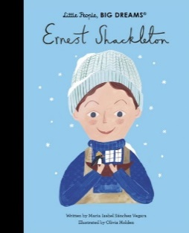

**Autumn Curriculum**

In Autumn, Year 6 will learn about the census and understand what it can tell us about the past. We will explore what the census can show about Victorian jobs, the suffrage movement and the interwar period. We will identify how the census changes and consider the usefulness and limitations of census data.

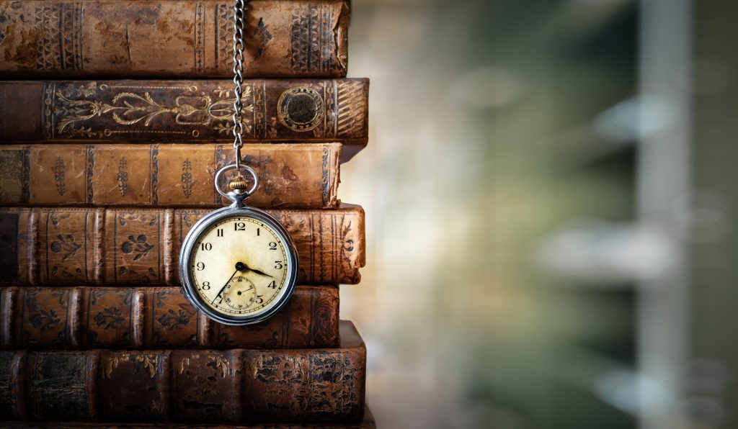

In Science, we will be studying living things and their habitats and looking to answer the question, how and why do we classify living things? We will also be understanding the importance of looking after our bodies and finding out how we can ensure our heart lasts a lifetime. This will include exploring the human circulatory system and how diet and exercise can effect this.

**Important Dates**

Medium Term Plan published on website – 12.09.25

Election Day – 06.10.25

Bikeability – 06.10.25 – 09.10.25

Halloween Disco – 22.10.25

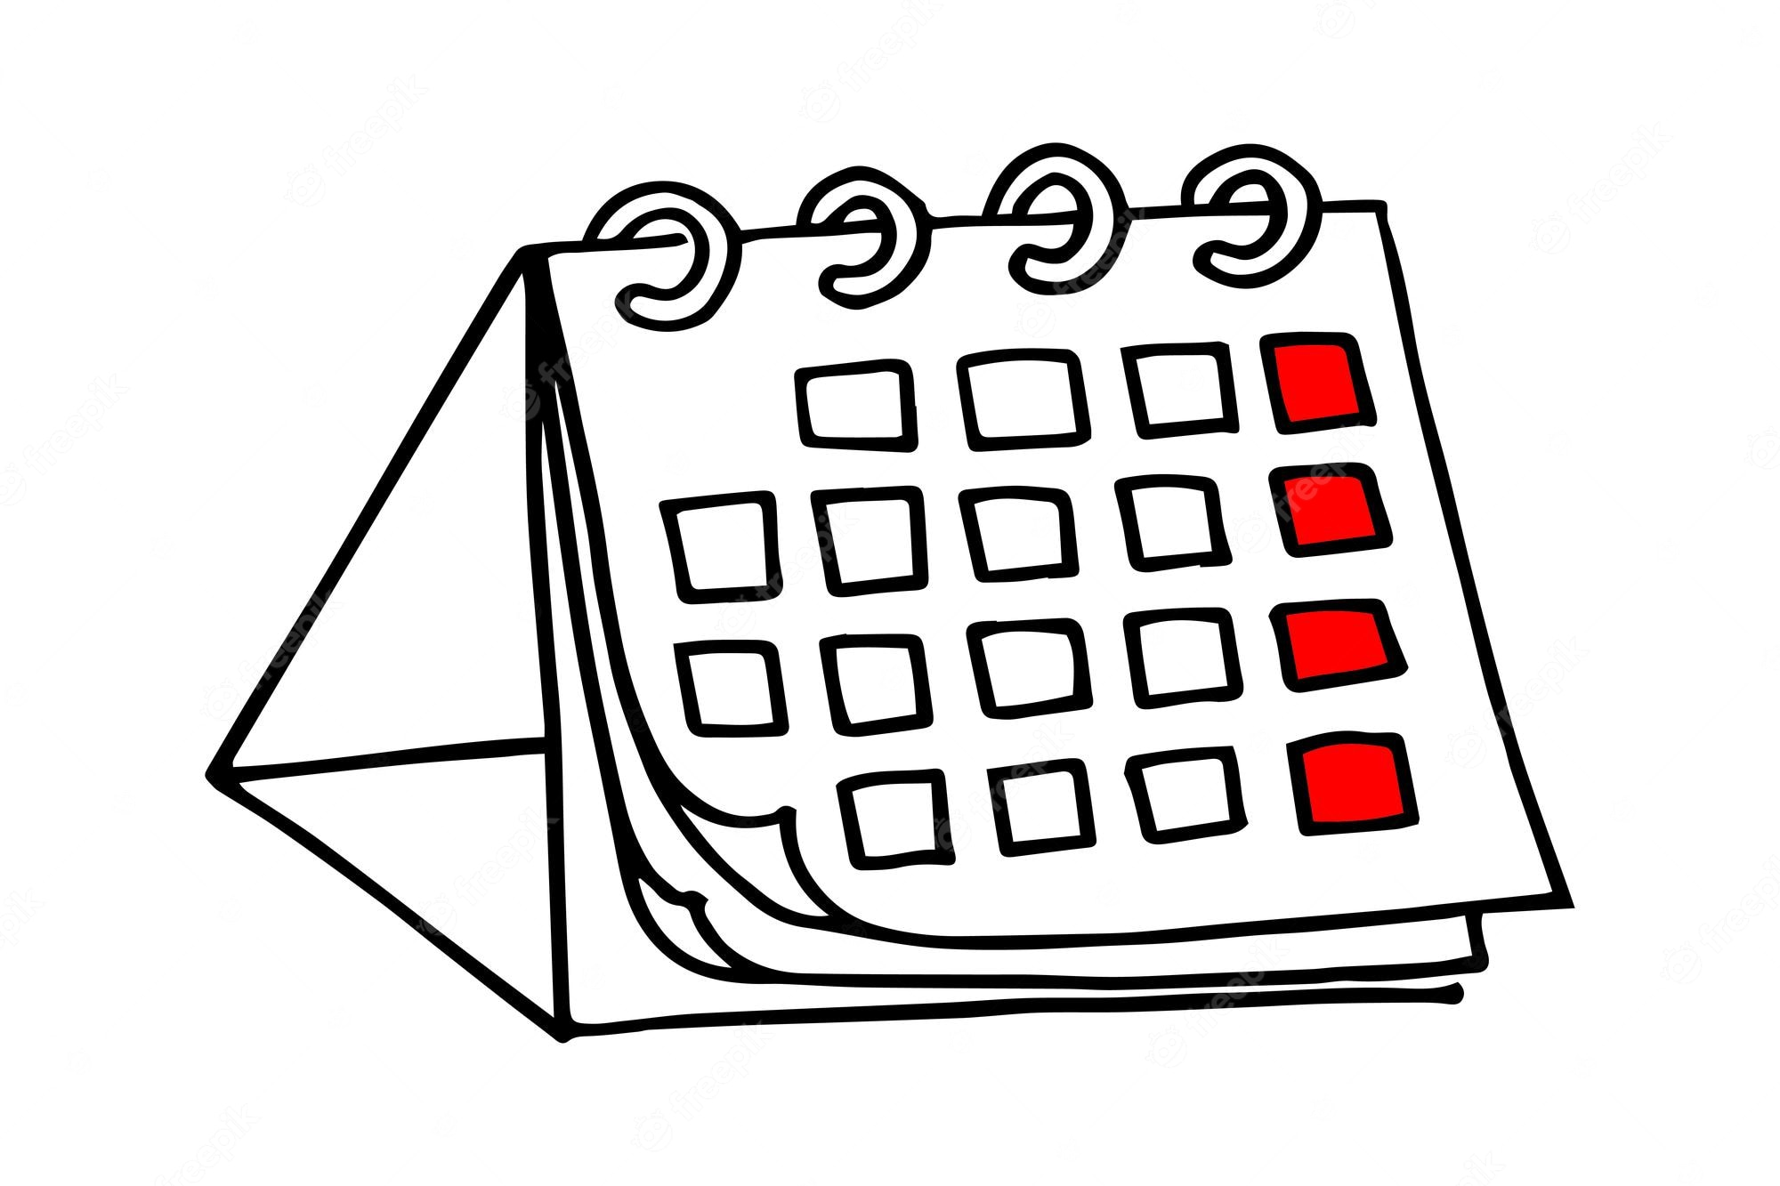

**PE**

Our PE is on a Thursday. Please come to school dressed in your full kit: black jogging bottoms, black hoody and house colour t-shirt. All clothing should be plain with no patterns or large logos.

**School Trips**

We are very excited for our school trip to the theatre to watch The Lion, The Witch and The Wardrobe on Wednesday 24th September. This will be a brilliant opportunity to see a live performance and we’re really looking forward to it.

**Water Bottles** Children are encouraged to bring water bottles to school as it is important that we are hydrated so we can work and be focused fully. Children are not to bring water bottles with spray functions on them. Make sure that your water bottle is brought in and full especially on PE days.

**Reading**

At Clayton Village, we want all children to be readers and it is a value we encourage. Not only for academics but more for joy and escapism from the everyday world.

We encourage all of our children to become avid readers and read at home frequently. They do not need to read aloud to an adult but you are encouraged to ask your child questions about what they have read. This year, to encourage reading your child has been provided with a reading journal: it is for them to present reflections/ reviews on the book they have been reading.

We will also be visiting the newly revamped library fortnightly so your child will have another opportunity to select a book.



**Miss Barraclough and Mrs Brown**

Year 6- Ernest Shackleton

Welcome back to another term in Year 6!

We hope you had a lovely summer break and are ready for lots of new and exciting learning.

Visit the School Website for this term’s medium term plan and updates of our learning.

Autumn Term 2025